**INTER VLAN SWITCHING PROJECT**

**REQUIREMENTS**

1. Cloud(Internet)
2. Router
3. Switch
4. 2 PCs

**Base IP Address for PCs**

* PC1 192.168.1.10
* PC2 192.168.2.10

**Network Design Image**

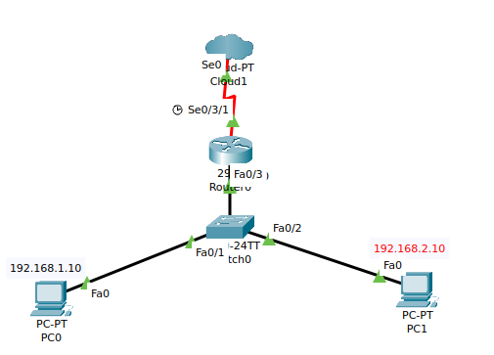

**Configuring The Switch**

**Creating VLAN 10(PC0)**

switcht>en

switcht>config t

Switch(config)#int fa0/1

Switch(config-if)#switchport mode access

Switch(config-if)#switchport access vlan 10

**Creating VLAN 20(PC1)**

switcht>en

switcht>config t

Switch(config)#int fa0/2

Switch(config-if)#switchport mode access

Switch(config-if)#switchport access vlan 10

**Configuring the link between the switch and the router**

switcht>en

switcht>config t

Switch(config)#int fa0/3

Switch(config-if)#switchport mode trunk

**Configuring The Router**

To avoid wasting the interface port between the router and the switch leverage the use of sub-interface technique

To create sub-interface we use dot (.) just after specifying the interface. For Example

***int gig0/0.10***

**In this case the configuration was as follows:**

**The first sub-interface**

*Router>en*

*Router#config t*

*Router(config)#int g0/0.10*

*Router(config-subif)#encapsulation dot1Q 10*

*Router(config-subif)#ip address 192.168.1.1 255.255.255.0*

**The second sub-interface**

*Router>en*

*Router#config t*

*Router(config)#int g0/0.20*

*Router(config-subif)#encapsulation dot1Q 10*

*Router(config-subif)#ip address 192.168.2.1 255.255.255.0*